Presented by: Herd immunity

Fontys university for Applied sciences

Rachelsmolen 1, 5612 MA Eindhoven



USER REQUIREMENTS SPECIFICATION

Herd Immunity simulation

Version 3.0

June 12, 2018

Contents

Members 2

Introduction 3

Acronyms 3

Functional Requirements Overview 3

Functional Requirements 3

Use Case Diagram 4

Use Cases 4

Measuring Functional Requirements 6

Non - Functional Requirements Overview 7

Non - Functional Requirements 7

Graphical User Interface 8

# Members

| Name | STN | PCN | Mail |
| --- | --- | --- | --- |
| Alalao Ali | 3107493 | 369697 | a.alalao@student.fontys.nl |
| Bolbol Obaida | 2956160 | 356432 | o.bolbol@student.fontys.nl |
| Nikov Kaloyan | 2961075 | 356847 | k.nikov@student.fontys.nl |
| Sikorska Iwona | 3197980 | 377191 | i.sikorska@student.fontys.nl |

# Introduction

This document will cover all functional and non-functional requirements along with Graphical user interface and the priority of the requirements.

# Acronyms

Acronyms & Definitions:

* Template – a configuration that can be filled in by a user to later be used for the simulation.
* Human statistics generation – refers to attributes that a human being can have that affect vaccine and viruses.
* Graphical User Interface (GUI) - a set of visual elements that allow the user to interact with a system.

# Functional Requirements Overview

The functional requirements listed below describe the technical functionality of the system. In other words, they show what the system should be able to do. They cover the different templates that are going to be needed by the software and the software itself along with the graphical user interface.

## Functional Requirements

|  |  |  |  |  |
| --- | --- | --- | --- | --- |
| # | Name | Actor | Description | Goal |
| 1 | Start simulation | User | The user will set configuration for the population, disease, vaccine, Environment, stepping type, number of simulations and then will start a simulation based on the configurations. | Actor initializes a simulation of herd immunity based on the set configurations. |
| 2 | Save simulation results into a file | User | Once a simulation has finished the user may save the results to a file. | Save simulation results into a file. |
| 3 | Export simulation configuration | User | After user has set desired configurations he can export them to a file. | Export simulation configurations to a file |
| 4 | Import simulation configuration | User | User can import simulation configuration from a file if that file has been created from the 'Export configuration' use case | Import configurations from the desired exported configuration file |

## Use Case Diagram

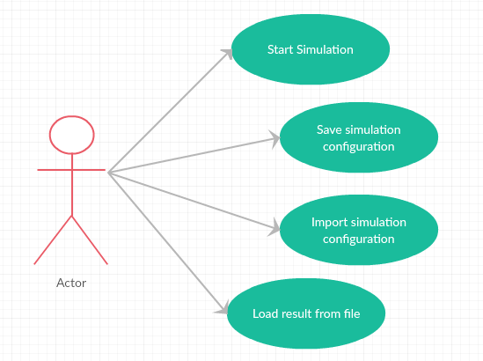

## Use Cases

**No: 1**

**Name**: Start simulation   
**Actor***:* User   
**Goal***:* Actor initializes a simulation of herd immunity based on the set configurations.   
**Description:** The user will set configuration for the population, disease, vaccine, environment and then will start a simulation based on the configurations.

**Main Success Scenario**:

1. Actor fills in the population information.
2. Actor fills in the disease and vaccine information.
3. Actor fills in the environment settings.
4. Actor chooses the stepping type.
5. Actor set the simulation Number.
6. System checks the information's validation.
7. System calculates vaccinated, unvaccinated, healthy vaccinated, healthy unvaccinated, infected vaccinated, and infected unvaccinated people.
8. System computes whether we get the level of herd immunity or not.
9. System gives the simulation results report and statistics name.
10. System saves the simulation results report and statistics into Debug folder in the application folder.
11. System shows the simulation of the result.
12. System shows the result report.
13. System shows a statistics report.
14. System shows a statistic graph

**Exceptions**:

5A. Actor set the simulation number to a more than one simulation

1. Use case will continue till it end step 10
2. Use case will not jump to step 13

6A. Entered information is invalid

1. System displays a message about it
2. Use case ends

**No: 2**

**Name**: Save simulation configuration  
**Actor**: User   
**Goal:** Save simulation configuration.  
**Description:** After user has set desired configurations he can save them.

**Main Success Scenario**:

1. Actor fills in the population information.
2. Actor fills in the disease and vaccine information.
3. Actor gives a name to a file.
4. Actor clicks on "Save" button.
5. System saves the configuration into a file.
6. System shows in the ‘Status’ label the name of the file that has been saved.

**Termination outcome:** [09:00:00] Saved ‘FileName’ to file

**No: 3**

**Name**: Import simulation configuration   
**Actor*:*** User   
***Goal:*** Import configurations from the desired saved configuration file   
***Description:*** User can import simulation configuration from a file if that file has been created from the ' Save simulation configuration' use case

**Main Success Scenario**:

1. User clicks on the combo box.
2. System shows a list of the files have been saved.
3. User chooses a file he or she want to load.
4. System overwrites all previously selected values in fields and puts in their place values from the imported file.

**No: 4**

**Name**: Load result from file   
**Actor*:*** User   
***Goal:*** Load statistic result graph from file   
***Description:*** User can load an old statistic result graph from a file which that file has been saved from the ' Start simulation’ use case

**Main Success Scenario**:

1. User clicks on the Load results from file button.
2. An Open File Dialog window appears.
3. User browses location and selects a file.   
   Default path where the file saved (~\projects\HerdImmunity\HerdImmunity\bin\Debug)
4. Users clicks "Open" button.
5. System opens a statistic graph.

**Exceptions**:

3A, 4A. User clicks on “Cancel” button instead

1. Use case canceled.

## Measuring Functional Requirements

Every template will have its impact in the end result and this is what we intend to use as a measure of its impact and check if it works as expected. Simulation has to be done as expected as well and to measure it we will do the same as for the templates. About the graphical user interface – every interactable and changing element will be tested if it works.

# Non - Functional Requirements Overview

The non-functional requirements listed below describe how the system should behave. They cover all the remaining requirements which are not covered by the functional requirements.

## Non - Functional Requirements

**Usability**

1. Application GUI should be user-friendly and give a clear imagination of what can be done with it.
2. The interface is easy to learn and navigate
3. Application can be used by the person without any technical background

**Stability**

1. Application should not crash at run-time and be bug free.

**Maintainability**

1. Application will be written in C# language using Microsoft Visual Studio IDE

**Performance**

1. Response time after some action takes place should not exceed 3 seconds.

**Testability**

1. The software will be tested before being released

**Supportability:**

1. Application should be run on PC with minimal specifications of:
   1. Processor (CPU): Intel Core i3
   2. Operating System: Microsoft Windows 7 Professional x64 SP1
   3. Memory: 4 GB RAM
   4. Storage: At least 1 GB of free space

# Graphical User Interface

